CLASSIFICATIO ASSIGNMENT:

DATASET TAKEN IS CKD:

STEPS TO SOLVE THE ASSIGNMENT:

1. PROBLEM STATEMENT:   
     
   DOMAIN : MACHIINE LEARNING – UN SUPERVISED LEARNING – CLASSIFICATION.
2. BASIC INFO ABOUT DATASET:  
   *THERE IS 399 ROWS AND 25 COLUMNS.  
   *THIS DATASET IS BASICALLY ALL ABOUT CHRONIC KIDNEY DIEASE PATIENT DETAILS WITH AGE AND ALL THINGS.
3. PREPROCESSING THINGS IS DONE IN THIS DATASET LIKE **GET_DIMMIES** WHICH IS CONVERTING THE NUMERICAL VALUES INTO CATACARICAL VALUES AND STANDARD SCALER WHICH IS ACTUALL CONVERING THE NUMERICAL VALEUS INTO PARTICULAR RANGE LIKE -3 T0 +3 VALUS.
4. I HAVE DEVELPED 6MODELS WITH HANDS ON AND ALSO USED DIFFERENT KIND OF PARAMETERS.
5. HERE I HAVE MENTIONES BELOW THE ALGORITHMS WITH IMAGE FORMAT:  
     
     
     
   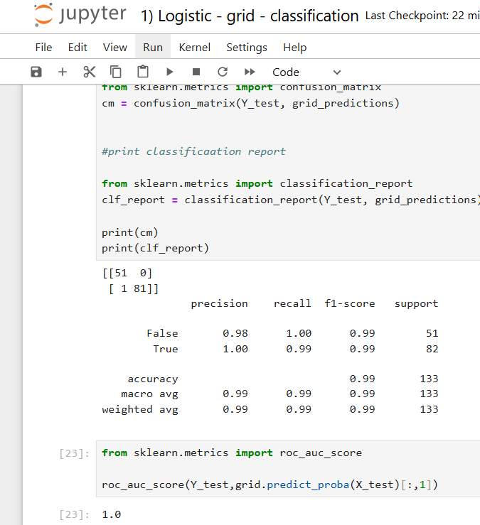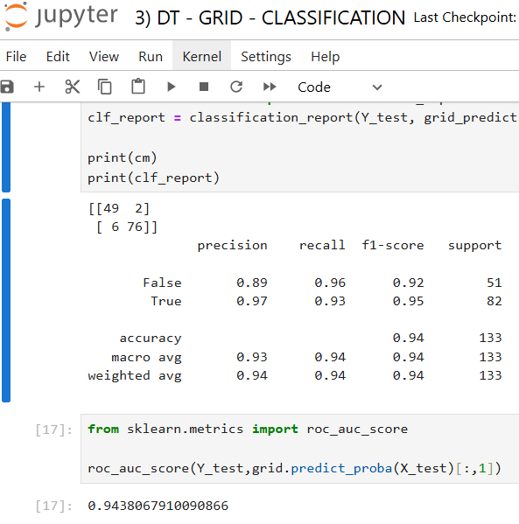  
     
     
   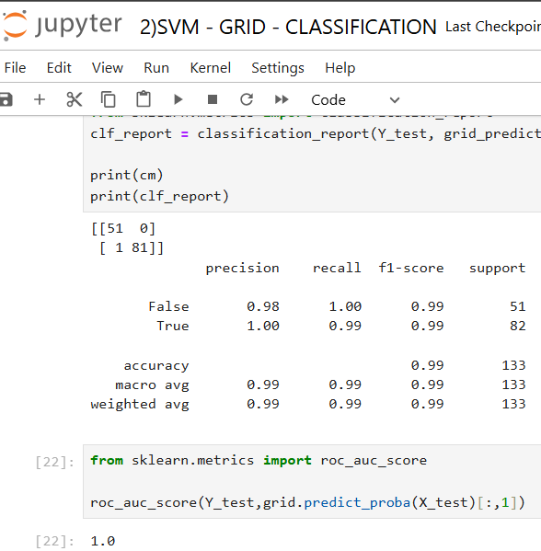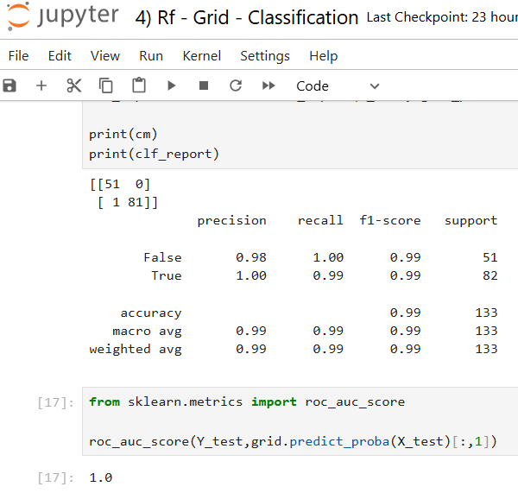  
     
     
   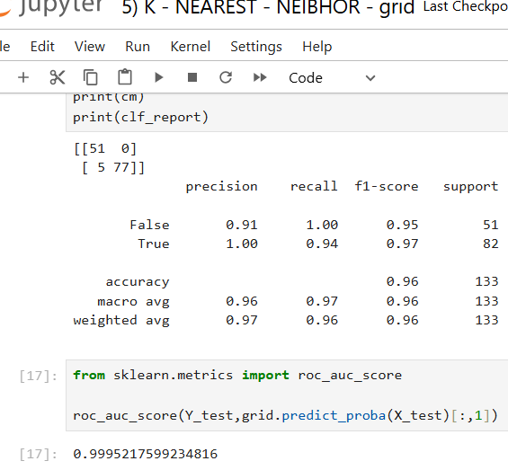  
     
     
   6) I HAVE TAKEN 3MODELS AS BEST MODEL FOR THIS DATASET  
    THERE ARE:
6. LOGISTIC CLASS GRID
7. SVM GRID
8. RANDOM FOREST CLASSIFICATION GRID